**ISEC 500 - Information Security Overview**

**Assignment 8 – Lab 6: Digital Forensics - Forensic Case Capstone**

The requirements for this lab are to capture the screenshot of the below steps from given sections and submit in the word document.

**Part 1**

**challenge #1**

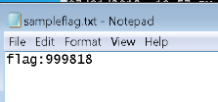

**challenge #2**

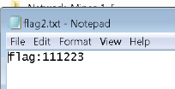

**challenge #3**

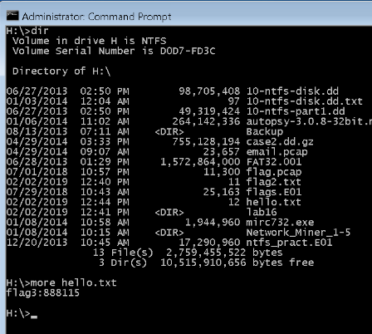

**challenge #4**

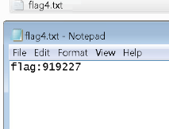

**challenge #5**

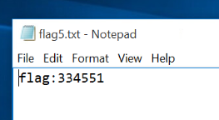

**challenge #6**

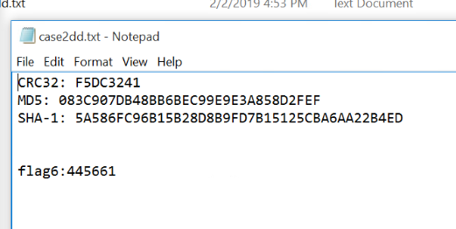 **Screenshots**

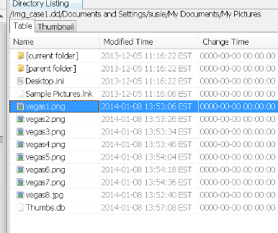

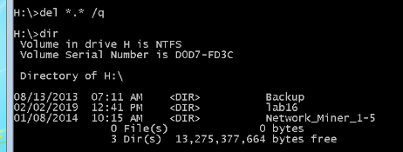

**PART 2**

I used to think dir only displayed folders and files on current directory. But it can do also search for a certain folder or file in current directory,

**dir name**

or in current directory and all subdirectories (by adding /s).

**dir name /s**

We can look for multiple file and/or folders at the same time too.

**dir Java Notes.docx /s :: Searches for the folder Java and file Notes.docx**

**dir “Java Notes”.docx /s :: Searches for the file “Java Notes”.docx**

**Autopsy is a very useful tool. Reminds me of the tool called “windirstat” which is used to analyz a current computer (not an image).**